Jurassic Coast article 1.
Old Harry Rocks.
The Old Harry Rocks are at the far eastern end of the World Heritage Site known as the Jurassic Coast. The cave, arch and stack features are typical of a Chalk coastline and are particularly well developed at this location between Studland and Swanage. It is possible to reach the site using the coastal footpath (South West Coast Path) either from Studland by the Bankes Arms Hotel (GR SZ037826) (postcode BH19 3AU)) or from Swanage. Another way is to take a boat trip out of Swanage and it is recommended that this is done on a sunny morning to see the coastline at its best. The view below is an aerial picture looking south west over the Old Harry Rocks and along the Ballard Down Chalk ridge which runs through to Lulworth Cove and White Nothe. The same Chalk ridge runs through the Isle of Wight.
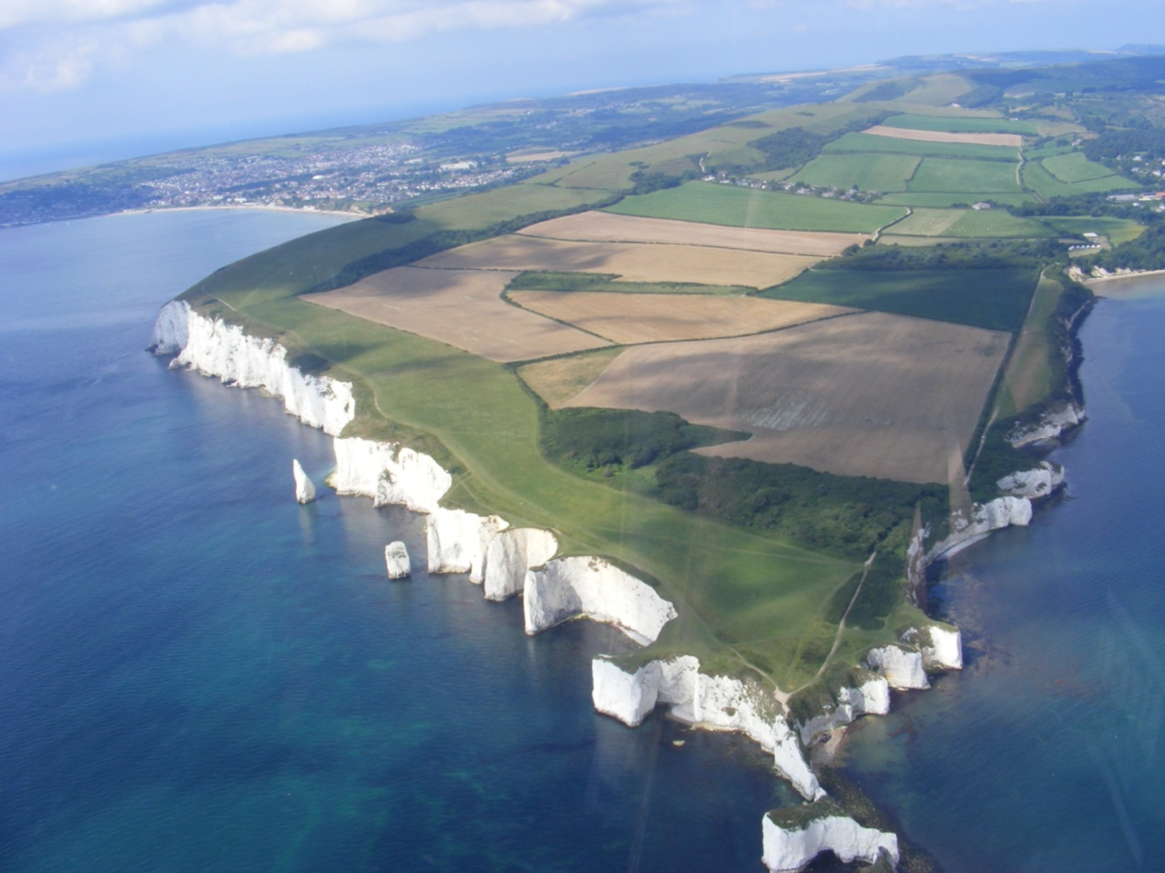
Old Harry Rocks

Swanage

Ballard Down Chalk ridge

The view below shows some of the features of the Old Harry coast from a boat. The features are due to the erosion of the Chalk by wave action. The sea picks out lines of weakness in the rock, called joints, and these are gradually opened to develop a cave. The cave can evolve into an arch as seen on the left of the picture below. Two other small arches can be seen in the middle of the picture. If the arch develops further and the roof collapses a stack is formed as seen on the right of the picture below. Such features are not unique to Old Harry and similar features can be seen in other Chalk coastline section such as around Flamborough Head in Yorkshire. However the presence of Old Harry and other notable landforms along the Dorset coast such as Lulworth Cove and Chesil Beach help to explain why it was designated as a World Heritage Site.
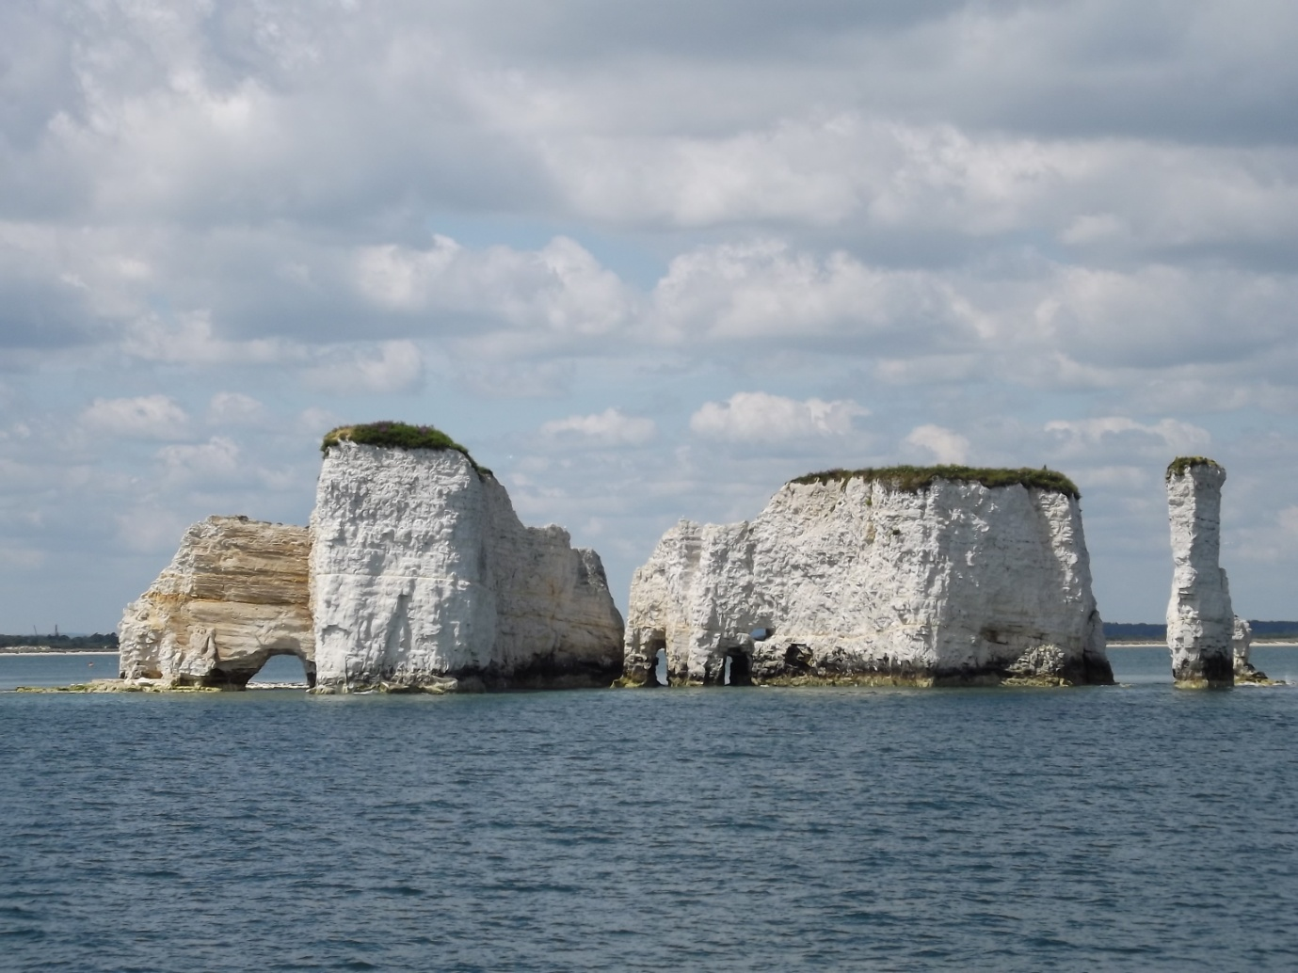
The orange coloured surface on the picture above is probably a fault along which the rock has moved in the geological past creating a grooved surface. It has now been exposed by the recent rock fall.
Rock falls also commonly occur. Wave action, normally with flint pebbles, undercuts the cliffs and eventually they are weakened and a cliff fall occurs. Further wave action washes away the fallen debris and the undercutting process starts again. Stormy weather such as that in the winter of 2014 is ideal for this to occur. The picture below shows a section south of Old Harry with a stack known as the Pinnacles and a large rock fall that occurred in the winter of 2014.
A word of warning, the coast can be dangerous and the cliffs are vertical. Rock falls can occur at any time so take care when visiting this or other coastal sections.

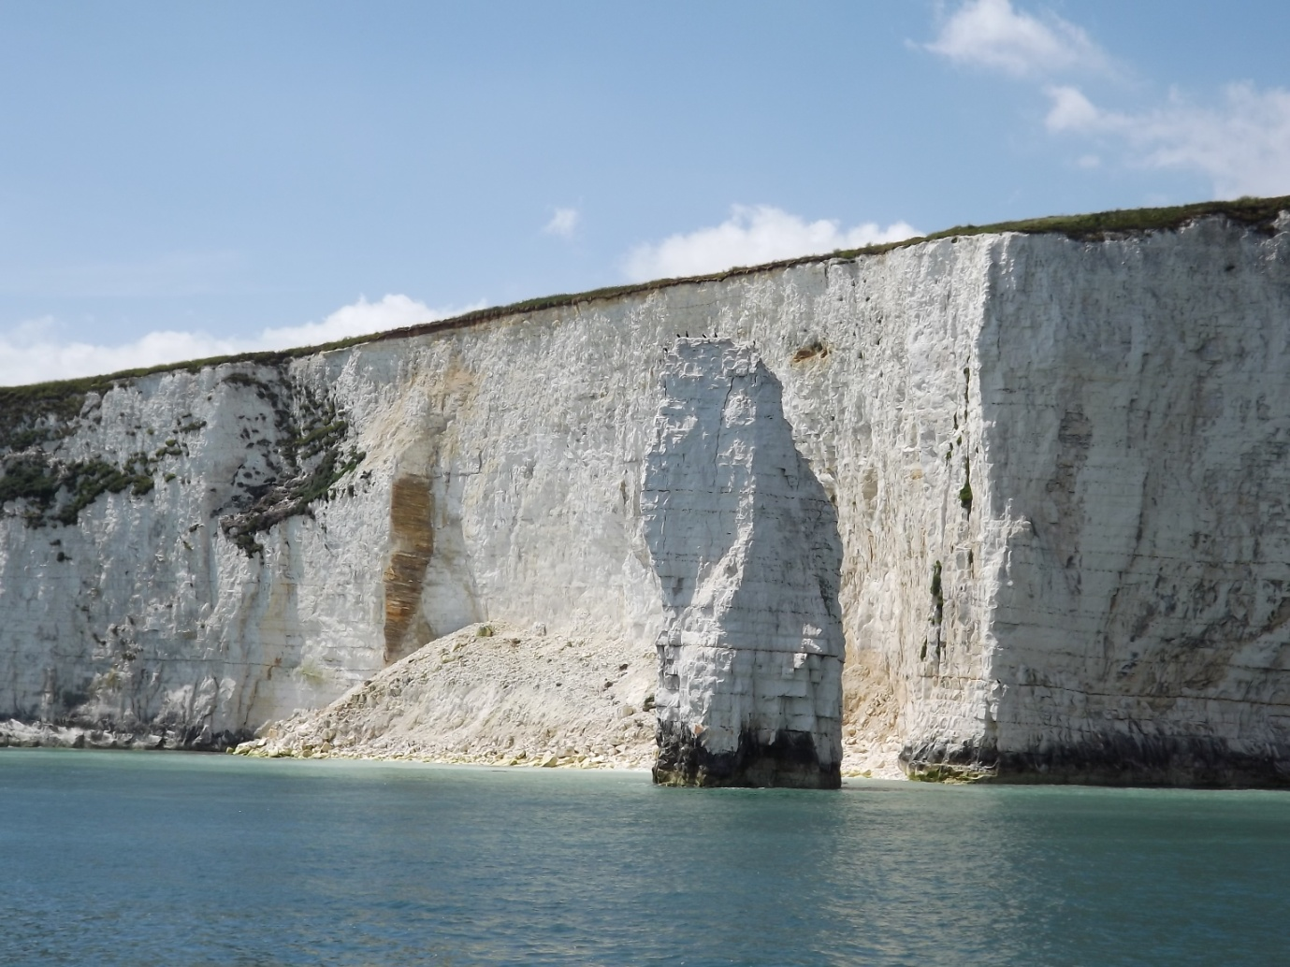

© Alan Holiday 2021.

